

THE ROVER



Project Increment-3

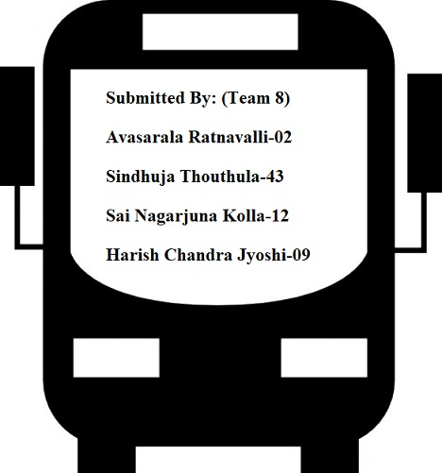

**1.Project Goal and Objectives:**

**1.1 Motivation:**

To provide the travel assistance to travellers in planning the tour, acquiring accommodation and the transportation facilities and also to overcome the difficulties faced by them like the language barrier and the restaurant/food availabilities, search for the tourist attractions has motivated us to develop an app with all the requirements integrated with augmented Reality, which would help them to give a best travel experience.

**1.2 Significance/uniqueness:**

This system has all the travel support and guidance options with augmented reality feature integrated in a single platform.

**1.3 Objective:**

Our idea is to develop a web application for a particular tourist attraction and implement augmented reality on it for a better tourist experience by integrating various facilities on a single platform.

**1.4** **System Features:**

* The user can login using any social networking sites like google or facebook or create an account and get assistance about the places he is planning to have a tour.
* Using Augmented Reality get the instant Text Translation of any text to their native languages.
* Acquire the shortest distance suggestions, Transportation facilities available, estimated time of reaching and the nearby restaurants and the accommodations along their way to destination.
* Gets to know the historical and the cultural information of a monument or a place and also how would they appear in a different season or in the past years.
* Travellers will never get bored during their long drives by playing educational games about their destinations.
* Obtain the weather Forecast even before reaching the destination in an interactive way with augmented reality feature.

**2. Third Increment report:**

**2.1 REST Services:**

* + - * OpenWeatherMap API
      * UClassify Sentiment Analysis API
      * Translate YANDEX API
      * Clarifai Visual Recognition API
      * Wikitude for ionic framework
      * Google GeoLocation API

**2.2 Detailed Design of Features**

* **Wireframes:**

**A screenshot of a cell phone

Description generated with very high confidence**

**A screenshot of a cell phone

Description generated with very high confidence**

* **Architecture Diagram:**

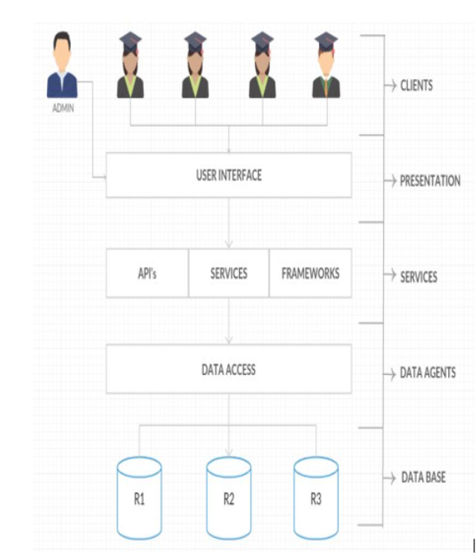

* **Sequence Diagram:**

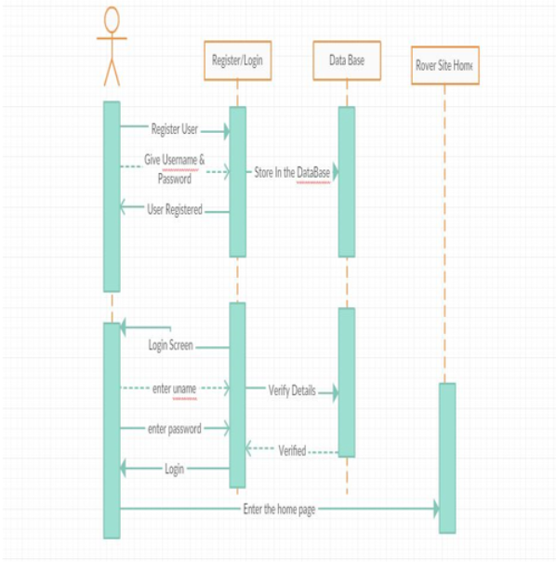

* **Sequence diagram of User Register and Login**

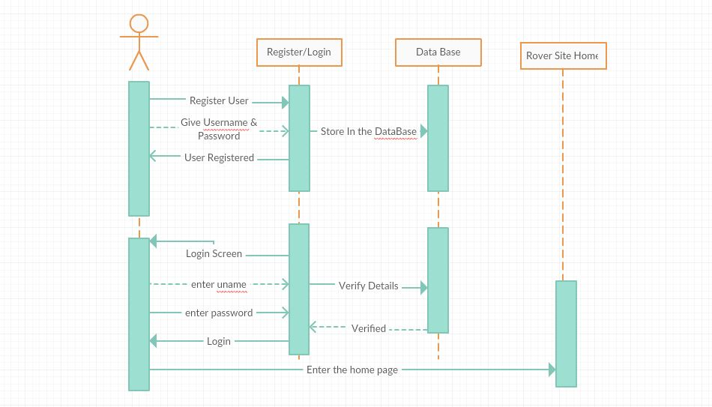

* **Class Diagram:**

**A close up of a map

Description generated with very high confidence**

**2.3 Testing:**

**Karma and Jasmine Unit tests:**

The unit test are performed using karma and jasmine plugins in webstorm.

**karma.config page**

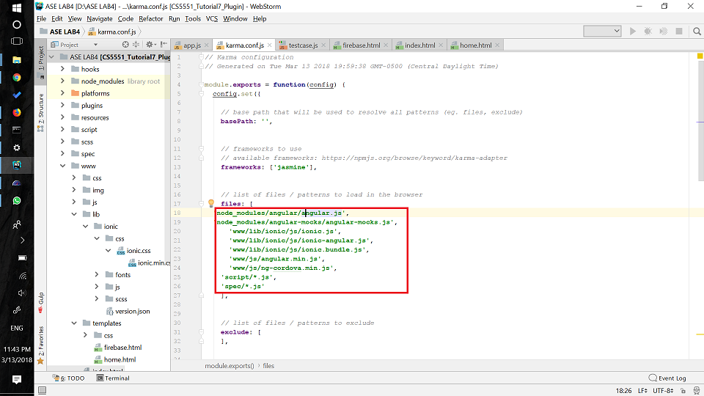

**Test cases js page**

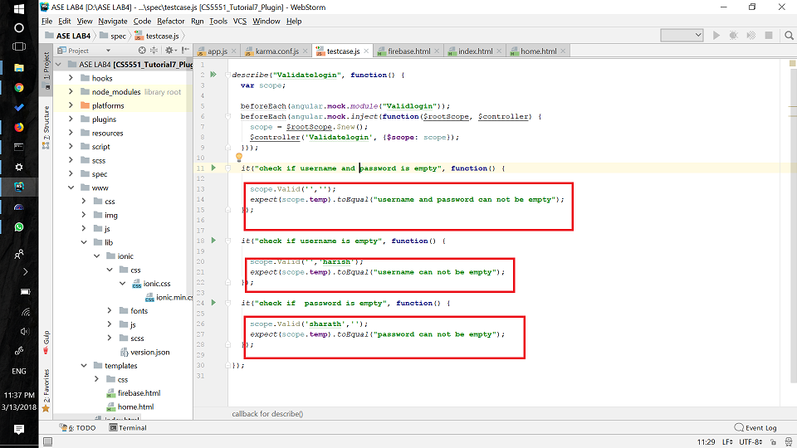

**Execution of test cases**

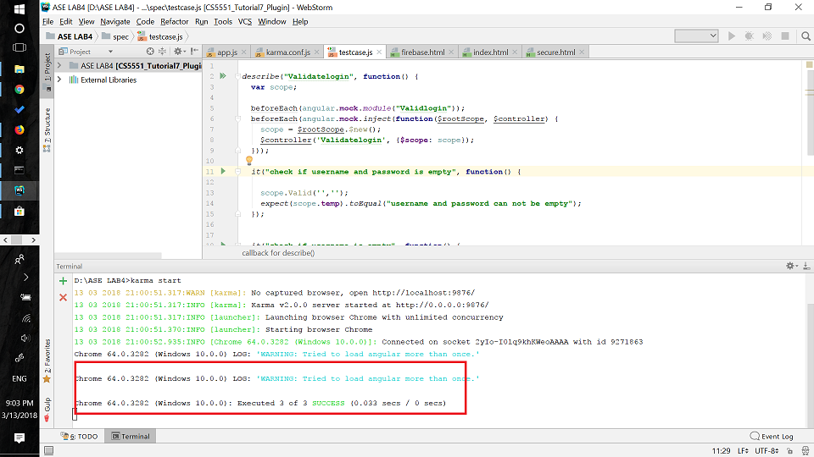

* **Unit testing:**

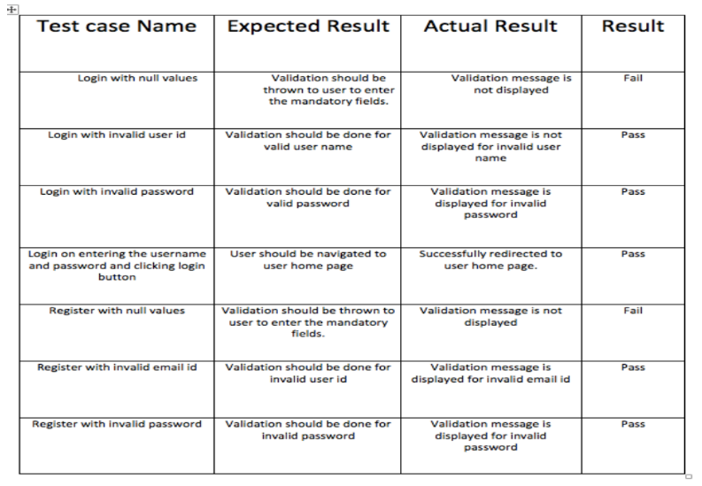

* **Yslow performance testing:**

Grade c for login page

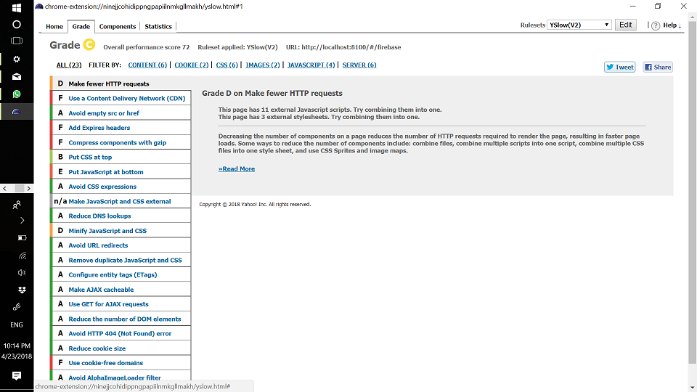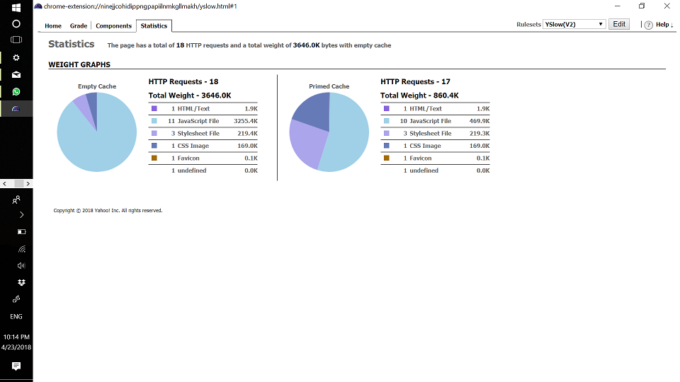

Graded C for home page

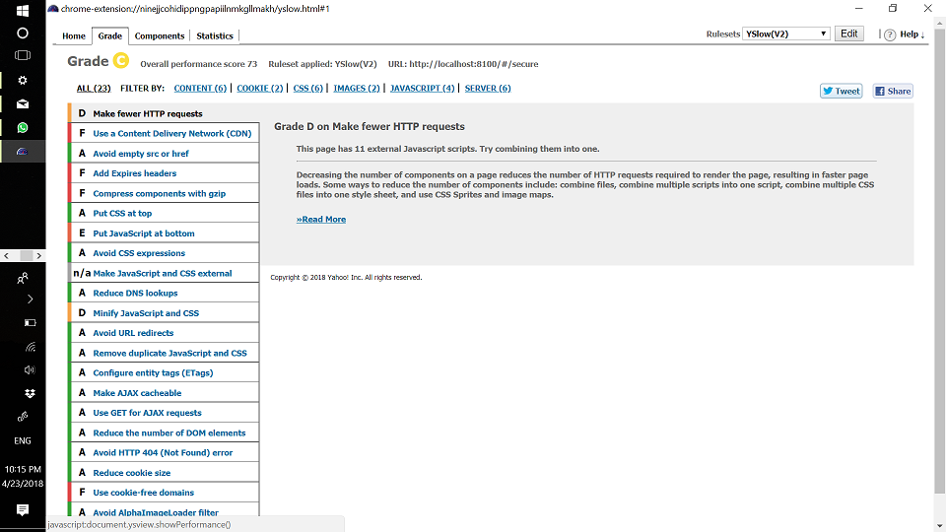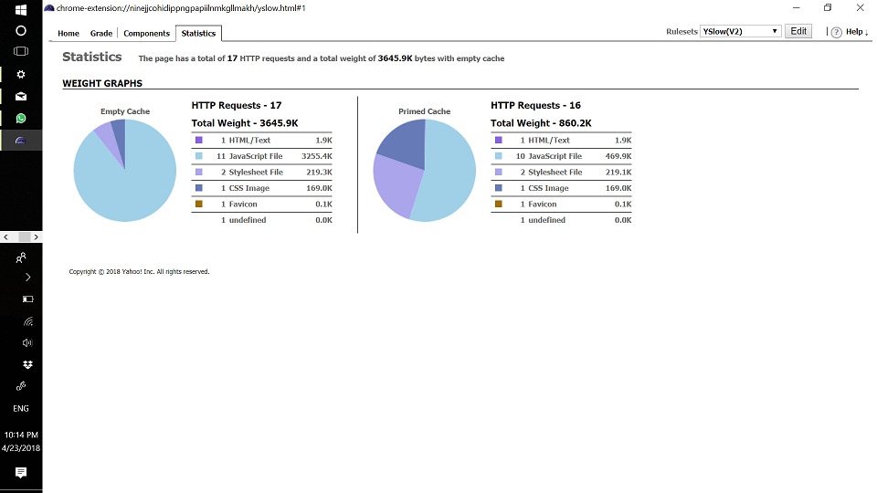

**2.4 Implementation:**

* **Mobile implementation**

**Below are the steps involved in creating the application**

**Login/Registration using Firebase Authentication.**

1.An ionic app is created with blank template.

2.Login and register pages with email and password are created.

3.Firebase Authentication is created for Login and registration

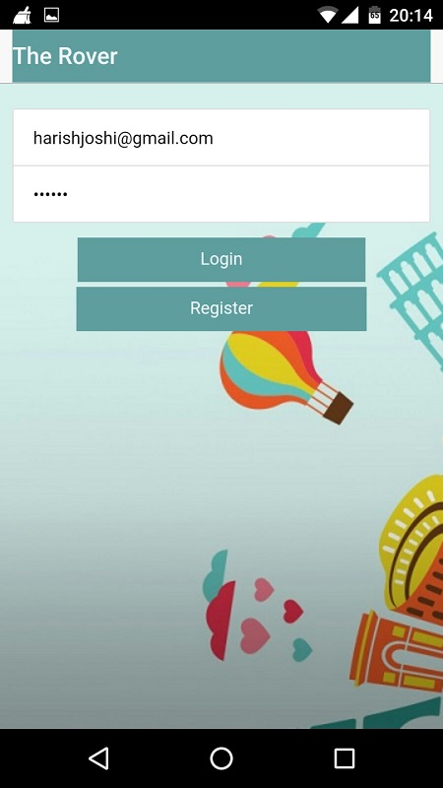

**Firebase Authentication**

All the login details are stored in firebase. The user needs to register once before logging in. Here is the history of login details stored in firebase.

A screenshot of a cell phone

Description generated with very high confidence

* After the user logins into the app, he can make use of all the services that are made available in the app. After signing in, the user will be redirected to the home page.

**Home page:**

Here we used different API’s for translating text, weather information, sentimental analysis and visual recognition and below are the screenshots attached.

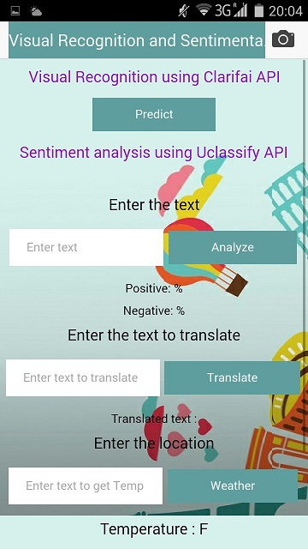

**Visual recognition API**

Here we made use of **Clarifai** visual recognition API where we used the camera feature for capturing the images and thereby predicting the connected things , objects and any particulars to that of the image captured.

**Step1:** Capturing Image using camera

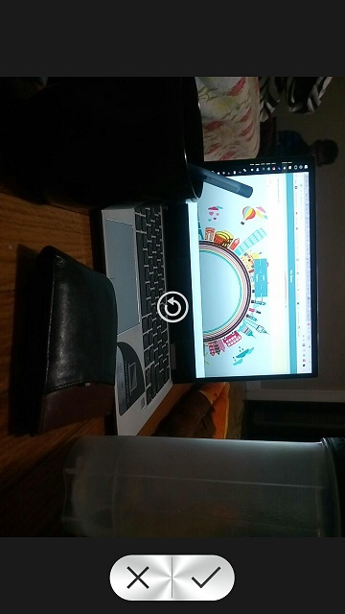

**Step2: Image uploaded alert**

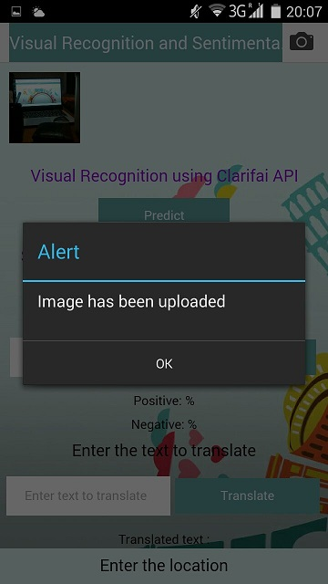

**Step 3: Prediction performed using the Clarifai API**

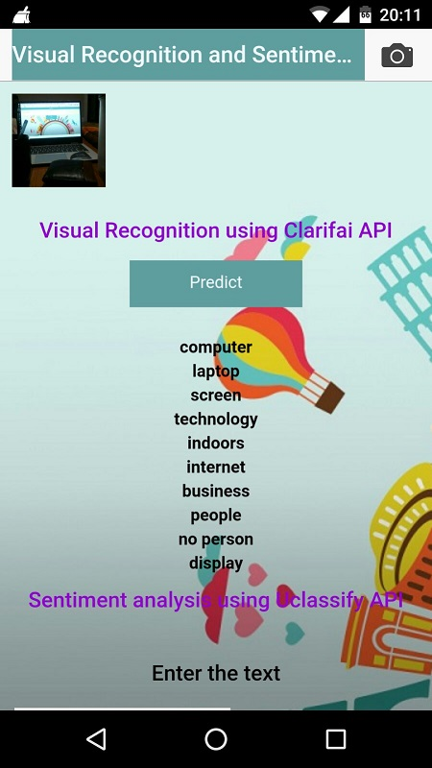

**Sentimental analysis, Translate, Weather API**

* We used  **Uclassify** **sentiment analysis** API .This API determines if a text is positive or negative. It’s trained on 2.8 million documents with data from Twitter.
* We used **OpenWeatherMap** API for getting the current weather and also the **Translate Yandex** API.

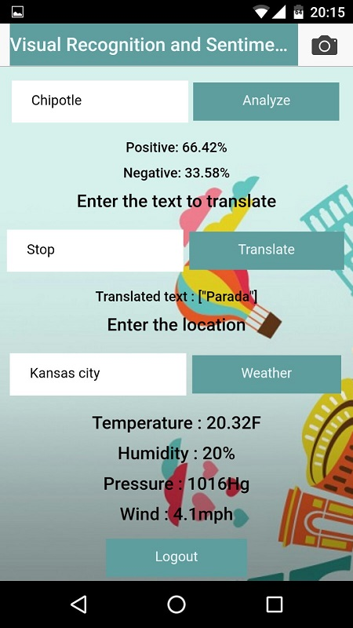

**Google Geo Location API**

In this Increment we also made use of **Google geo location** API where we get the current location.

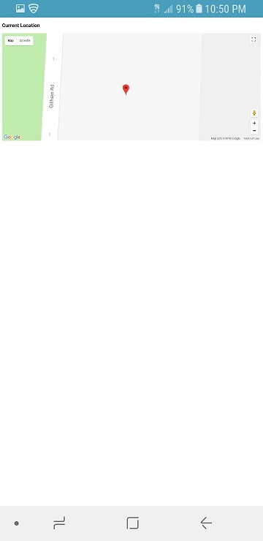

We developed the project in ionic framework. Following are the screenshots of the app in web browser.

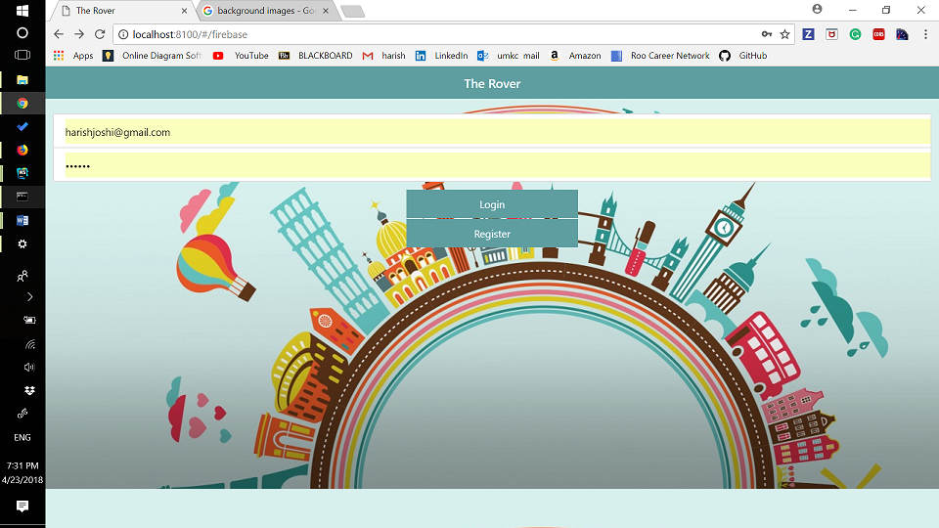

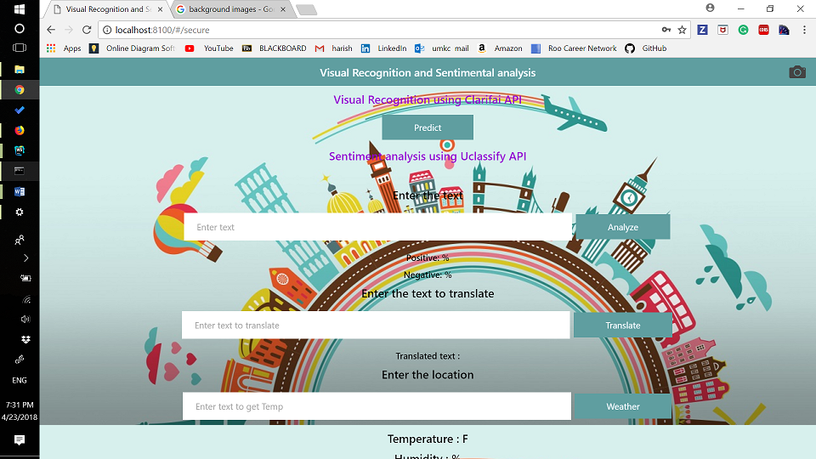

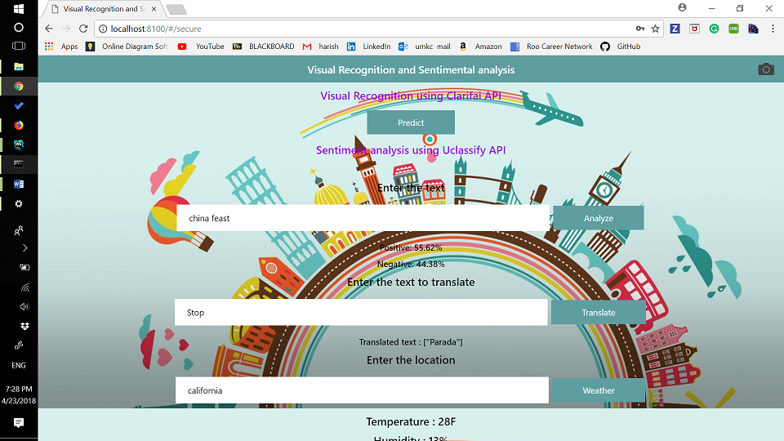

* **Augmented Reality:**

We used wikitude SDK for ionic to get nearby restaurants and gas stations in Augumented Reality. Following are the screenshots of Augumented Reality View.

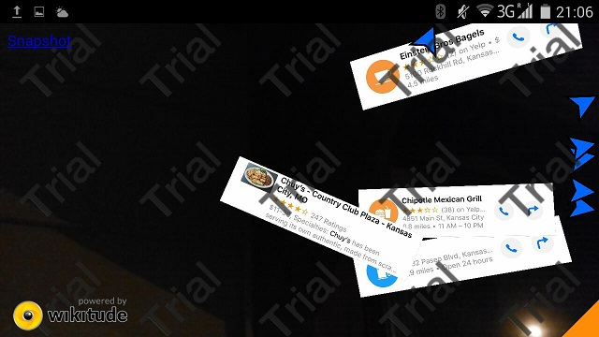

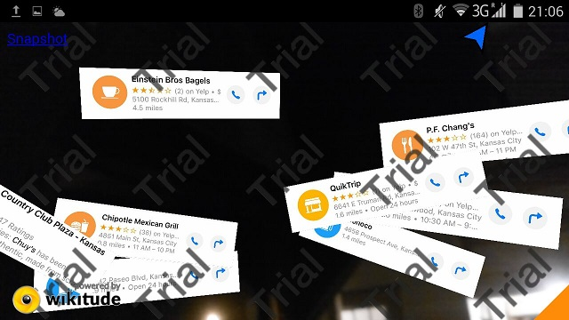

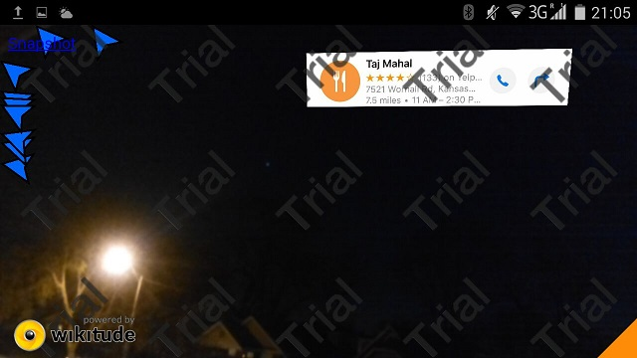

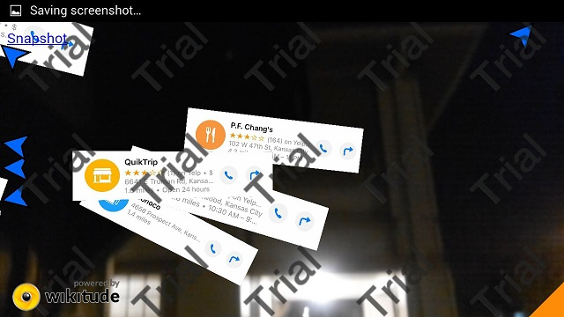

**2.5 Deployment:**

* We deployed our app to smart phone. Following are the screenshots.

 

* We also deployed our service into Heroku server. Here is the link of app running in Heroku server.

[**https://whispering-wildwood-11675.herokuapp.com/#/firebase**](https://whispering-wildwood-11675.herokuapp.com/#/firebase)

**2.6 Project Management:**

**Implementation status report:**

Work completed:

**1.Augumented reality:** Developed augumented reality application using wikitude SDK. This feature will be get nearby restaurants and gas stations.

Responsibility and time taken: Harish– Designed and implemented and feature (21 days)

**2. Changing UI:** Changed the user interface to deploy it into the mobile.

Responsibility and time taken: Sindhu and Ratnavalli- changed the user interface(21 days)

**3. Heroku server:** deployed the service in Heroku server and installed required dependencies.

Responsibility and time taken: Nagarjuna and Sindhu-Installed required dependencies. (10 days)

**4.Deploying in mobile:** deployed the application in mobile.

Responsibility and time taken: Ratnavalli-deployed the app in android platform and fixed some errors in the process.

**Concerns**

Facing some issues while integrating the wikitude.

**Future work:**

Need to implement social media analysis, will be completed in 3 days.

Following are the screenshots of the Issues and Burndown chart in ZENHUB

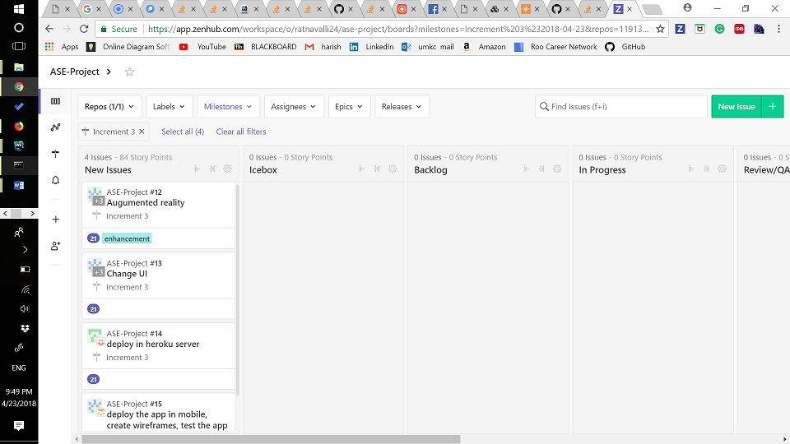

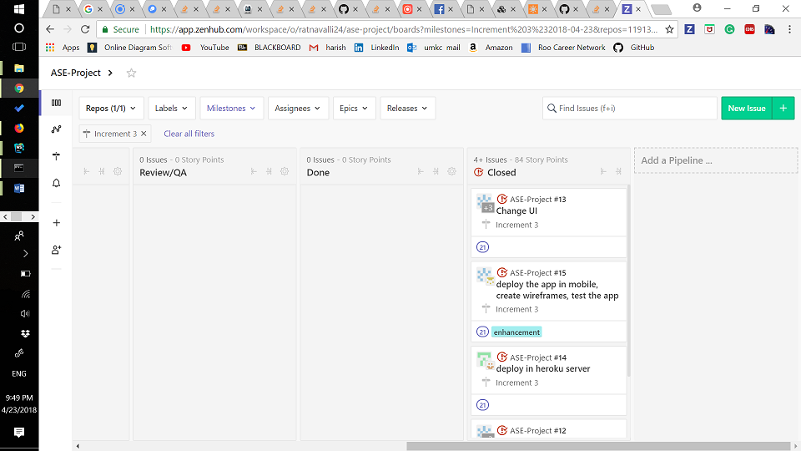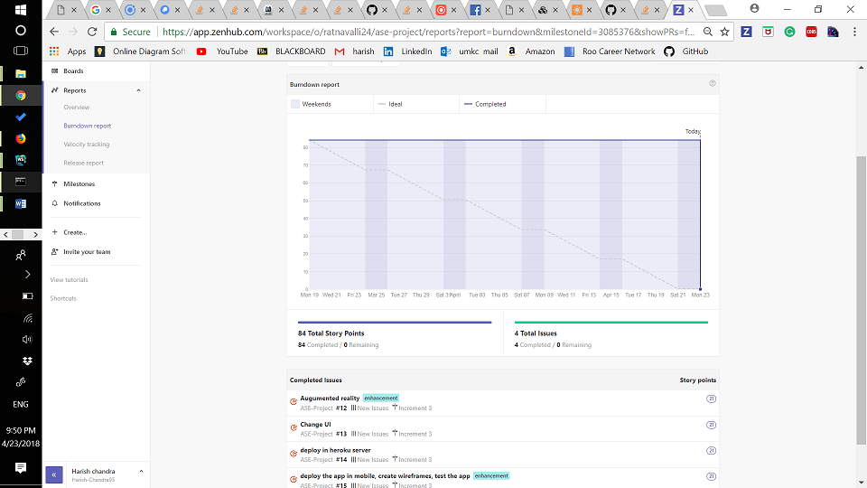

**2.7 References:**

[**https://www.wikitude.com/**](https://www.wikitude.com/)